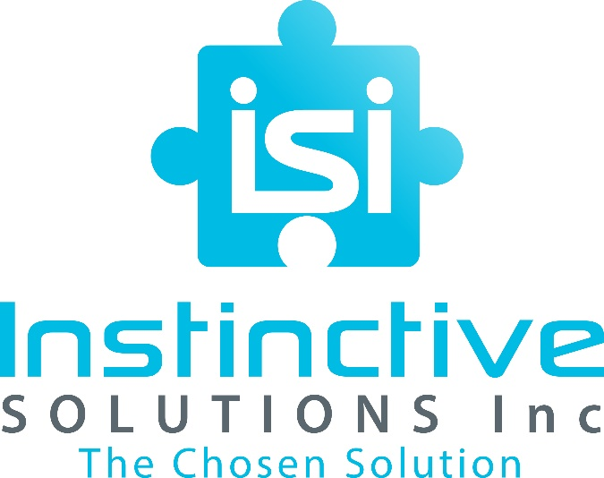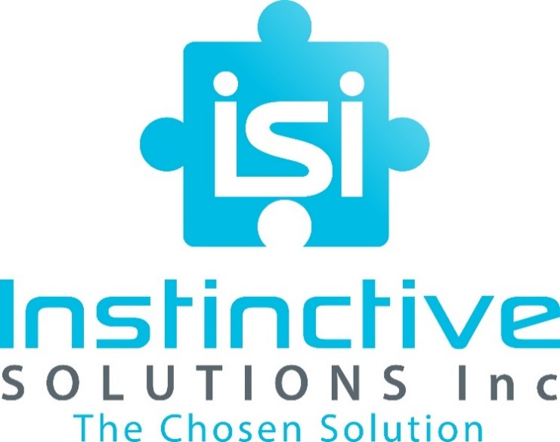

**AT A GLANCE**

**DUNS:** 068108135

**CAGE:** 85PW4

**CERTIFICATIONS**:

* SBD, GA-DBE
* SWOB, SDVOSB, Hubzone, and 8a Certified*Partners*

**PHONE:** 678.856.5580

**EMAIL:** info@CHOOSEISI.com

**WEBSITE:** www.CHOOSEISI.com

**LOCATION:** Atlanta, Georgia

**h**

**WHO WE ARE**

Instinctive Solutions, Inc. (ISI) is a global management consulting firm specializing in Information Technology, Management Consulting, Training & Education, and Multi-Media Services. ISI has a proven track record of providing our customers with high impact solutions in industries such as: information technology, education, defense, healthcare, insurance, media and communications. Our team leads complex initiatives that are coupled with decades of management experience, reliability, and integrity to solve our clients’ biggest challenges.

Mr. Michael Moss is the founder and Chief Executive Officer of ISI and embodies 16 years of experience in the information technology, professional development, training, project & program management, and Healthcare industries. Some of Mr. Moss’s clients include: Oracle, the United States Coast Guard, Transportation Security Administration, Department of Homeland Security, and the City of Atlanta. With a comprehensive skill set and ability to engage with professionals at every stage and echelon of a project; Moss has managed over $150 million in projects and contracts while also executing contracts from concept to completion.

**OUR TEAM**

* Malika Humphries: COO
* Lewis Chapman: Government Liaison
* Jeff Telfare: Director - Information Technology
* Donavan S. West: Director-Professional Development/ Training & Education
* Nicki Lynch: Director-Multimedia /Communication

**OUR MISSION**

**CORE COMPETENCIES**

**Training & Education**

* Curriculum Development
* Custom Training Solutions
* Educational Services
* Instructional Design
* Instructor-Led and Web-Based Training Implementation
* Management & Professional Development

**Information Technology**

* Application and Web Development
* Custom Computer Programming Services
* Data Management, Processing and Hosting
* Database Architecture
* System Analysis and Design
* System Integration

Our priorities are at the intersection of customer satisfaction and performance! ISI is committed to providing quality, innovative, and first-rate experience to every project, client, and stakeholder that we serve. Through developing an intimate understanding of our client’s needs, ISI can leverage its robust and diverse cadre of services for current and future endeavors.

**Management Consulting**

* Administrative Support
* Documentation Preparation
* Program & Project Management and Consulting
* Public Relations & Communications
* Staff Augmentation

**Multimedia**

* Marketing and Advertisement
* Motion Picture Production and Distribution
* Photography
* Professional Graphic Design
* Videography

**WHY CHOOSE ISI MISSION**

* Experienced Professionals
* Commitment to Quality
* Strategic Mix of Technology and Business Relations
* Innovative Solutions

**www.CHOOSEISI.com**

**Information Technology**

US Coast Guard – ISI was responsible for development and delivery of Training for an Oracle upgrade for the Department of Homeland Security. The scope of the project included an overhaul of the Departments’ training curriculum for all employees and stakeholders.

**Administrative and Management Consulting**

Toyota – ISI provided management consulting of multiple global projects for the company including the merger of US, Japan, Canada, and South American locations and plants. ISI single handedly guided Toyota to a streamlined approach to management of import and export needs across the company.

**Professional Development and Education**

Kaiser Permanente – Through training and professional development services, ISI worked closely with Kaiser executives to solidify relationships with insurance providers, patient care, and ambulatory services; saving the company millions in employee development expenses while developing a rapport with clients and stakeholders alike.

**Multimedia/ Communications**

In pursuit of its production, direction, stage management, graphics, and full operation of multiple programs objectives; ISI has facilitated major projects for the purposes of assessing common objectives and key performance indicators in an effort to work closely with multiple Directors in various productions, enabling concurrent tracks of development. This increase in presence, impact and outcome is the ISI way!

**NAICS CODES**

**Primary: 541512 - Computer Systems Design Services**

**Secondary Codes**

* 512110 - Motion Picture and Video Production
* 518210 - Data Processing, Hosting, and Related Services
* 519130 – Internet Publishing and Broadcasting and Web Search Portal
* 541430 - Graphic Design Services
* 541490 - Other Specialized Design Services
* 541511 - Custom Computer Programming Services
* 541513 - Computer Facilities Management Services
* 541519 - Other Computer Related Services
* 541611 - Administrative Management and General Management Consulting Services
* 541612 - Human Resources Consulting Services
* 541614 - Process, Physical Distribution and Logistics Consulting Services
* 541618 - Other Management Consulting Services
* 541690 - Other Scientific and Technical Consulting Services
* 541820 - Public Relations Agencies
* 541890 - Other Services Related to Advertising
* 541910 – Marketing Research and Public Opinion Polling
* 541921 - Photography Studios, Portrait
* 541922 – Commercial Photography
* 561110 - Office Administrative Services
* 561312 - Executive Search Services
* 561410 - Document Preparation Services
* 561920 - Convention and Trade Show Organizers
* 561990 - All Other Support Services
* 611420 - Computer Training
* 611430 - Professional and Management Development Training
* 611699 – All Other Miscellaneous Schools and Instruction
* 611710 – Educational Support Services
* 621399 - Offices of All Other Miscellaneous Health Practitioners
* 621511 - Medical Laboratories

**CORE COMPETENCIES**

**Naics codes**

**PARITAL LIST OF CLIENTS COMPETENCIES**

**Private**

* CapGemini
* Deloitte
* Oracle
* Auto Trader
* Piedmont Healthcare
* Toyota
* MARTA
* General Electric (GE)

**Government**

* US Coast Guard
* Transportation Security Administration
* Dept. of Homeland Security
* Emory University
* City of Atlanta
* U.S. Navy
* University Systems of Georgia
* Henrico County Gov’t

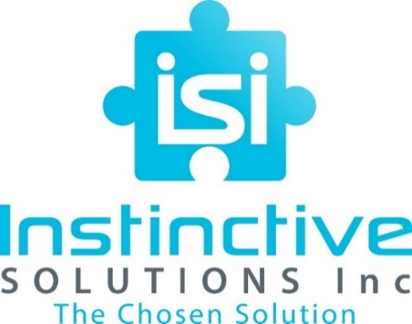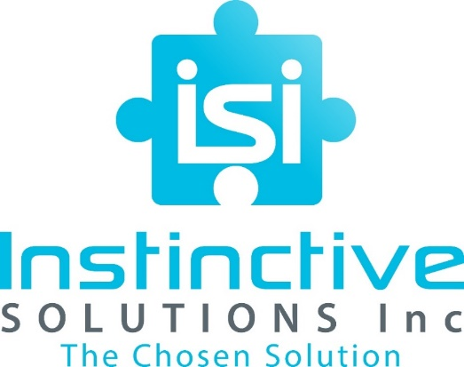

**www.chooseISI.com**